Decision Analysts:

Muhammad Usama – 261882 – m.usama@stud.uis.no

Asim Sabir – 261876 – as.sabir@stud.uis.no

PROJECT SUBMISSION

Automated Home financing

**MOD 500 – Modeling for Decision Insights**

**UNIVERSITY OF STAVANGER**

**30th November 2020**

**Executive Summary**

Everyday corporations, governments and individuals face different situations in which they need to find an optimal solution or a suitable decision policy, which can help them steer their way out of a complex situation. In order to find this optimal decision or policy, corporations and governments use different analysis techniques, they assign probabilities to uncertain events, determine the associated cost of each event and decision alternative and then they arrive at the most beneficial decision.

Decision analysis (DA) is a systematic, quantitative, and visual approach to addressing and evaluating the important choices that businesses, governments or individuals sometimes face. DA finds its application in R&D projects, Investment projects, business ventures, product launches and even in personal decisions. Statistics and probability theory form the basis of Decision analysis, the techniques used in decision analysis help the analyst to model an opaque situation into transparent models, where all underlying costs and uncertainties are defined in a transparent manner and a series of steps are taken to solve the problem.

This project is focused on finding an elaborate decision policy for the Customer Service Representative (CSR) department of a Home Financing company, which can be adopted by the CSR in the CSR-customer interactions and will result in maximum profit for the company. The company under study in this project is Dream Home Financing, it offers loan packages to customers who are looking for loans in order to buy, build or repair their homes. The analyst will use old data from company’s database and determine whether the CSR-customer interaction will be successful or not, and then they will define a policy based on the values and probabilities of uncertain variables which are associated with the calculation of revenue generated by the company over the loan term and it’s Net Present Value (NPV). The values of these uncertain variables may change from customer to customer but in order to define a decision policy, they are modelled into probability distribution using historical data from previous CSR-customer interactions.

Table of Contents

**Introduction** 3

Project Description 3

**Framing & Formulation** 4

Assumptions 4

Insights from Dataset: Uncertain Variable Selection 4

Influence/Dependency Assessment 7

Conditional Probability Calculation for Loan_Status (Loan Success) 8

Base Model Decision Tree 9

Net Present Value Calculation 9

**Deterministic Structuring** 10

Value Model & Cash Flow Diagrams 10

Base Model 11

Value Sensitivity 13

**Probabilistic Evaluation** 14

**What-If, Scenario and Option-Analysis** 17

**Model Appraisal** 18

**Considerations of other factors** 19

**Recommendation and Conclusions** 20

**Attachments** 20

**References** 20

# **Introduction**

Dream Home Financing is a home financing company, its leadership has 28 years of experience in lending and real estate since 1992. The company provides consumers with an education in various mortgage programs and lending alternatives. They also have an extensive network of lenders which offer a wide variety of loan packages. **[1]**

Among all industries, insurance domain has the largest use of analytics & decision analysis methods. This decision analysis project is aimed towards helping the company define a decision policy, by identifying suitable customer segments and offering them loan package which is most profitable to the company by calculating the net present value of the interest included in the loan payments. The suitable customer segments are defined by using the data from previous deals between different customers and Dream Home Financing.

### **Project Description**

The dataset of the project is present on Kaggle, and it contains very detailed information regarding the interaction between the company CSR and customers. **[2]** These details include Marital Status, Education, Credit History, Loan Amount, Loan Term etc. The inference diagram for the decision analysis is shown in Figure 1.

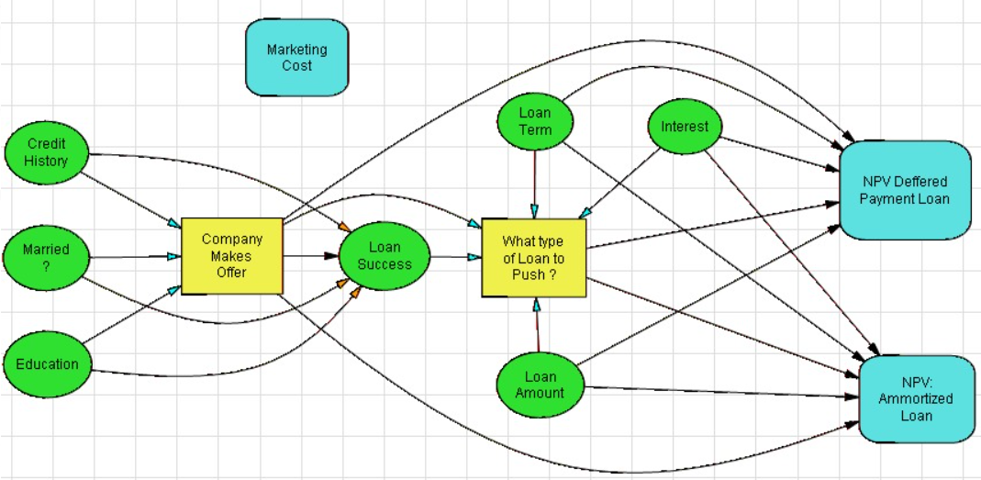

**Figure 1: Inference Diagram of the Base Model**

In figure 1, it is shown that this decision analysis activity aims to identify the customer segments which are more likely to get a loan and suggests these segments to the CSR team, which is then tasked to sell these customers, the loan packages which will be most profitable to the company (Deferred Payment Loan / Amortized Loan), these loan packages are decided by the company leadership and more options can be added. Hence there are two decision to be made, first being whether the CSR should approach customer and make an offer and second being if the customer is interested in getting a loan which type of loan package should be offered to the customer. The dependencies between chance nodes are inferred using correlation coefficient values from the correlation matrix, the details of which will be discussed in 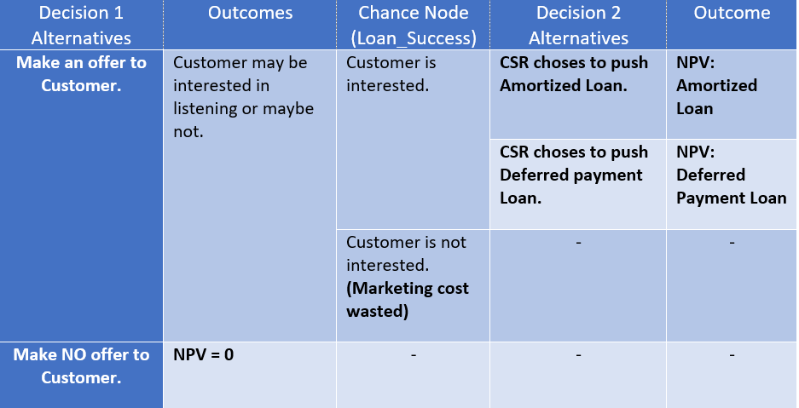the framing and formulation phase.

**Figure 2: Layout of available decisions to Dream Home Financing**

# **Framing & Formulation**

### **Assumptions**

The decision scenario described above in Figure 1, is based on some assumptions which are kept as much realistic as possible. The three main assumption are as follows,

1. The Minimum Acceptable Rate of Return (MARR) is assumed to be at 3% compounded monthly. **[3]**
2. The Marketing cost is set to 4500 Dollars, this is the cost including all the expenditures including maintenance of data, researching for and approaching customer.
3. The interest Rates offered by banks in US are range from 3.00% to 4.5%. [4] The company has also chosen to offer interest rates within a similar range, but this uncertainty is modelled to vary normally with mean of 3.745% and Standard Deviation of 0.433% and used as compounded monthly in NPV calculations.
4. Dream Home Financing is Risk-Neutral because of the large portfolio to maintain.

### **Insights from Dataset: Uncertain Variable Selection**

A small snippet of the first five rows of dataset can be seen in Figure 3. In the DPL Enterprise version this dataset can be easily imported from excel and modelled into a decision tree. DPL Enterprise takes care of calculation of the dependencies and resulting conditional probabilities. In MOD 500, DPL Professional Version is provided, and the above-mentioned function is not included, hence the decision analysts will thereby employ python to do this job for them.

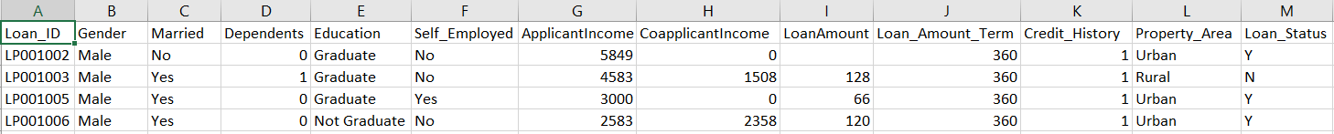

**Figure 3: Raw Data from excel file of Dataset, [Loan_Term (months), Loan_Amount (thousands)]**

It can be seen that almost 11 uncertainties are supposed to influence the Loan_Status (not including Loan_ID, as it is just an index). If all these uncertainties are considered, then the resulting conditional probability tree for Loan_Status will be enormous, hence, to keep the analysis straight forward only Education, Married, Credit History, Loan_Amount and Loan_Term are considered. This point is further validated by the Correlation Matrix in Figure 4.

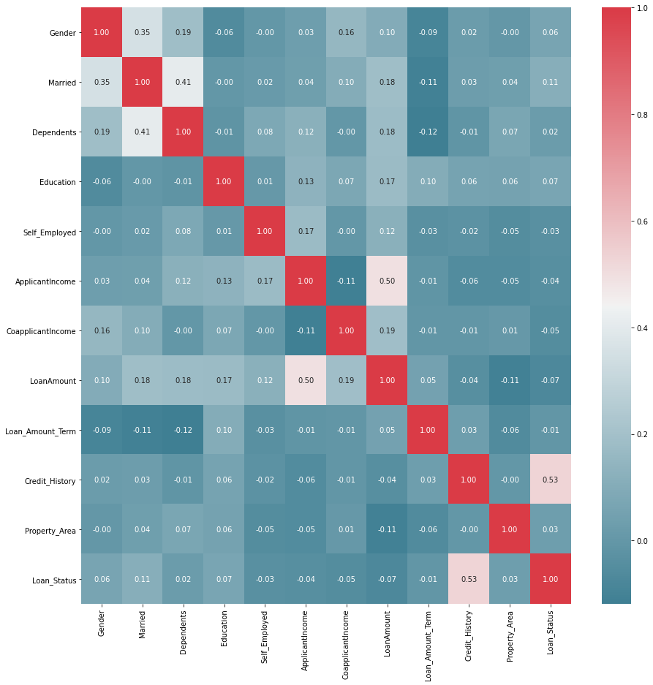

**Figure 4: Correlation Matrix after considering all uncertainties**

**(from Jupyter Notebook: “Probabilities and Dependence Assessment.ipynb”)**

In Figure 4, the last column (or row, can be both) shows the correlation between Loan_Status and other variables, it can be observed that only Credit_History is moderately correlated to the Loan_Status, i.e. the value of correlation coefficient is 0.53. The correlation coefficient below 0.2 and even 0.2 is considered a sign of very weak correlation and is usually ignored in investments, 0.8 and above shows strong correlations and 0.5 means moderately correlated. **[5]**

Decision analysts will still consider the uncertain variables of Education, Married, Credit History, Loan_Amount and Loan_Term regardless of the fact that some of these are weakly correlated, as they will allow the analysts to come up with a more detailed and diverse decision policy for Dream Home Financing.

**Probability Assessment**

The calculations of marginal and conditional probabilities along with estimations of dependencies are carried out in Jupyter Notebook attached with the project under the name, “*Probabilities and Dependence Assessment.ipynb”.* The results obtained from the calculations will be discussed below. The marginal probabilities of the Credit_History, Married and Education are shown in Table 1.

|  |  |  |
| --- | --- | --- |
| MARGINAL PROBABILITIES | | |
| Credit History | | |
| Alternatives | Good | Bad |
| Probabilities | 0.850662 | 0.149338 |
| Married | | |
| Alternatives | Married | Not Married |
| Probabilities | 0.651042 | 0.348958 |
| Education | | |
| Alternatives | Graduate | Not- Graduate |
| Probabilities | 0.790657 | 0.209343 |

**Table 1: Marginal Probabilities of Credit_History, Education and Married**

Loan_Amount is a continuous random variable where as Loan_Term is a discrete random variable with 8 possibilities according to the dataset, for making a more general decision policy it is better to represent these with some theoretical distributions by conducting KS-Test and Chi-Square Test respectively. The code and results of KS Test and Chi-Squared Test are mentioned in Jupyter Notebook (“*Probabilities and Dependence Assessment.ipynb”*) and excel file *(“Chi_Square-LoanTerm.xlsx”*) respectively. **[6] [7]**

Table-2 shows the best suited distributions along with their parameters for Loan_Term and Loan_Amount. The distributions are automatically discretized by DPL using 3-point approximation.

|  |
| --- |
| DPL Discretization Results |
| Loan_Amount |
|  |
|  |
| Loan_Term |
|  |
|  |

**Table 2: Probability Distribution Discretization Results**

### **Influence/Dependency Assessment**

The influence arcs in between chance nodes in Figure 1 (Influence Diagrams), are yet to be justified, it is still not clear why Loan Amount and Loan Term do not influence Loan status, for this purpose another correlation matrix will be drawn for the selected variables. Figure 5 shows correlation matrix for the selected variables, it can be observed that only Credit History is mildly correlated with the Loan Status (Correlation Coefficient of 0.53), in order to define a more effective and elaborate decision policy decision, analysts consider the fact that Married and Education chance nodes also influence Loan Status, also this basic information (Married and Education) is readily available to the company about customer segments not only from their own database but from many public databases.

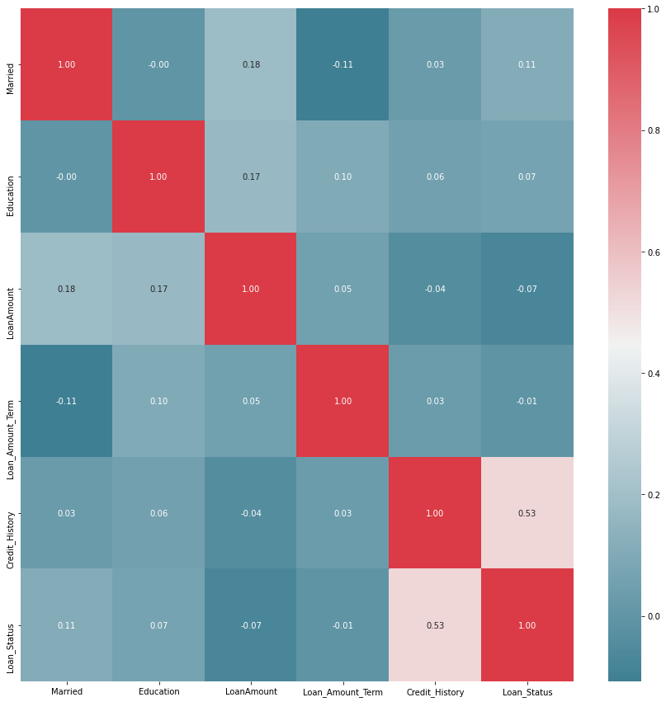

**Figure 5: Correlation Matrix for the selected variables**

**(from Jupyter Notebook: “Probabilities and Dependence Assessment.ipynb”)**

### **Conditional Probability Calculation for Loan_Status (Loan Success)**

The Loan_Success is dependent on Credit_History, Education and Married, Figure 6 shows the conditional probability tree, the values are calculated using pandas in python, and details are attached in the Jupyter Notebook (“Probabilities and Dependence Assessment.ipynb”).

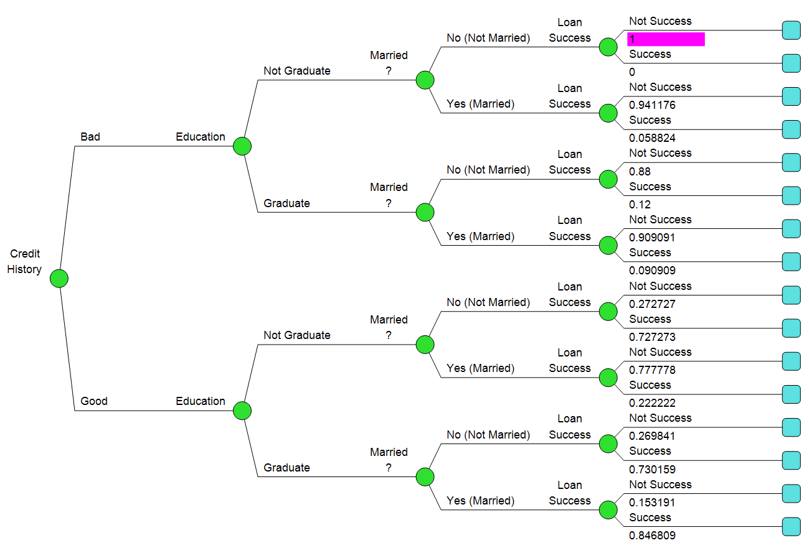

**Figure 6: Conditional Probability Tree for Loan_Success**

### **Base Model Decision Tree**

The probability assessment and influence arcs assessment has been completed, lets revisit the problem statement, and discuss the resulting decision tree. Figure 7 shows the decision tree made as a result of the Influence Diagram in Figure 1.

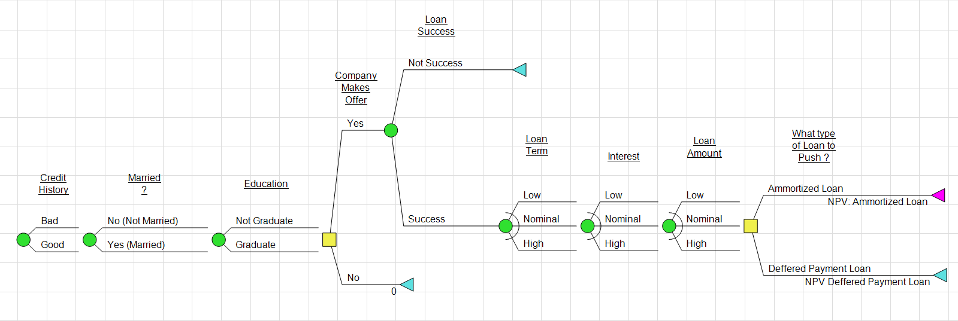

**Figure 7: Decision Tree of the Problem Statement**

**(Loan_Status is renamed as Loan Success just for ease of understanding)**

This Decision Tree in Figure 7 can be thought of as a representation of a single customer/CSR interaction. While the "Company makes offer?" decision is a downstream decision because it's preceded by several uncertainties, those uncertainties represent characteristics of customer accounts that can be readily observed rather than events that will play out in the future. The goal of the decision analysis is to reveal a decision policy (that is, a set of decision rules) that can be applied to all customers contacted. Basically, there are certain market costs that are involved in making the effort of making contact with customers. If this cost is 20 dollars, it would mean that it will cost the company 20 dollars to attempt to sell a loan policy to a given customer. In some scenarios, the company’s customer service representatives, attempt to sell the Loan Package. Once the offer is extended, and if customer is interested then customers are provided with a loan package based on the values of Loan Term and Loan Amounts provided by the customer, the values and probabilities for the variables 'Loan Term' and 'Loan Amount' are observed from previous data for setting up a decision policy which helps the CSR decide what kind of offer, should be given to these customers based on the NPV amount of interest they will be paying to the Company in form of installments in future.

Hence, there are four possible scenarios in the problem above,

1. Dream Home Financing does not make an offer to the customer based on his/her data.
2. The company makes an offer, but the loan is not successful (Customer not interested).
3. The company makes an offer, the customer is interested, company pushes Amortized Loan.
4. The company makes an offer, the customer is interested, company pushes Deferred Loan.

### **Net Present Value Calculation**

The company is offering two types of house loans i.e. Amortized Loan and Deferred Payment Loan. An Amortized loan is a type of loan that requires the borrower to make scheduled, periodic payments that are applied to both the principal and interest. An Amortized loan payment first pays off the interest expense for the period; any remaining amount is put towards reducing the principal amount.**[8]** Whereas a deferred payment loan allows the borrower to postpone the interest payments on the loan for a specified time.**[9]** The key difference between these two loans is payment schedule. In Deferred Payment Loan, the borrower must pay all amount (principal and interest) at the end of loan term while in Amortized Loan, the customer needs to pay equal EOM installments (principal and interest) each month for the whole term period. To determine which loan package to push to the customer, decision analysts calculate the Net Present Value (NPV) of each loan package using MARR of 3% compounded monthly. NPV method is used in capital budgeting and investment planning to analyze the profitability of a projected investment. A positive NPV indicates that the projected earnings generated by investment (in present dollars) exceeds the anticipated costs. In this case, Loan package with higher NPV is the better choice. In order to calculate the NPV, cash flows of the payments need to be calculated first on the interest rate at which the company is pushing the loan package.

# **Deterministic Structuring**

The deterministic structuring of the problem statement consists of Value models, Cash flow models, base value models and Value sensitivity analysis.

### **Value Model & Cash Flow Diagrams**

Following interest compound factors will be used to calculate cash flows for both packages.

1. [A|P, i%, Loan term] to calculate the monthly installment (Amortized Loan) i.e. *A = P*[A|P, i%, Loan term]***[10]**
2. [F|P, i%, Loan term] to calculate the future payment at the end of loan term (Deferred Loan payment). i.e. *F = P*[F|P, i%, Loan term]* **[10]**

*where,*

i - interest rate of loan,

P - principal amount (Loan amount),

F - future value of principal amount,

A - monthly installments.

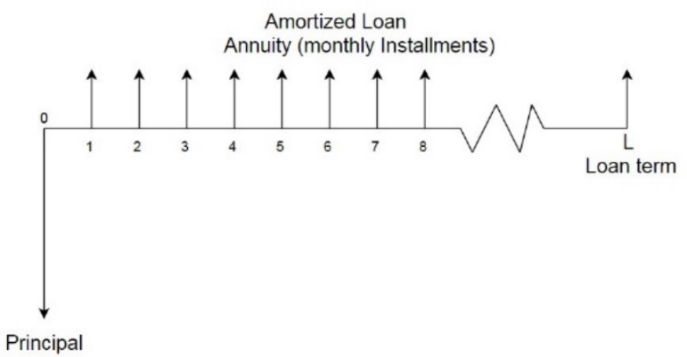Figure 8, shows the cash flow diagram for Amortized Loan, in the beginning of the venture, the principal amount is paid by Dream Home Financing to the customer, then the customers repays the amount along with interest in installements until the end of the loan term.

**Figure 8: Cash Flow Diagram for Amortized Loan**

Figure 9, shows the cash flow diagram for Deferred Loan Payment alternative, since this alternative allows the borrower to postpone the interest payments on the loan for a specified time, hence the amount is just paid in one installment and there is simply one cash out-flow and one cash in-flow.

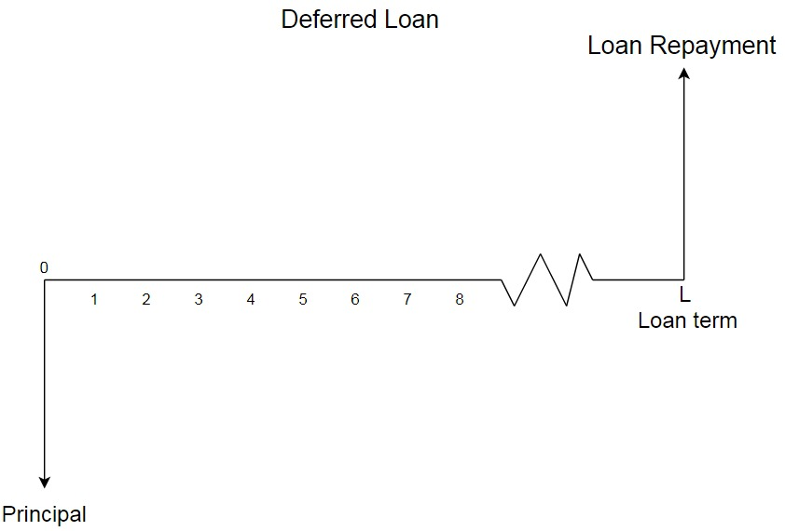

**Figure 9: Cash flow diagram for Deferred Payment Loan**

Once the cashflows are known, NPVs (MARR) can be calculated as follows:

### **Base Model**

Table 3 shows values of base case and calculation of Amortized payment and Deferred payment on base values.

|  |  |
| --- | --- |
| Marketing Cost ($k), MC = | $4.50 |
| **Variables** | **Base** |
| Loan Term | 379 |
| Loan Amount ($ Thousands) | $194.00 |
| Interest of loan to customer (Compounded monthly) | 4.00% |
| **Amortize Loan (Base Case) A = Loan Amount*[A|P,4%/12,379]** | |
| Loan payment($ k), A | $0.90 |
| **Deferred Loan (Base Case) F = Loan Amount*[F|P,4%/12,379]** | |
| F at the end of loan term ($ k), F | $684.78 |

**Table 3: Base values and Loan payments**

**(From Excel file: CashFlows and NPVs.xlsx, Sheet name = Base values)**

Table 4 illustrates cashflows and NPV of Amortized loan for base case at MARR.

|  |  |  |  |  |
| --- | --- | --- | --- | --- |
| **Amortized Loan (CFs) - Base Case** | | | | |
| Monthly Interest = i = 4%/12 = | | | | 0.33% |
| MARR = | | | | 3.00% |
| Monthly Payment = A = | | | | $ 902.29 |
|  | **a** | **b = a*i** | **c = A – b** | **d = a - c** |
| **Months** | **Beginning Balance** | **interest** | **Principal** | **Ending Balance** |
| 0 | $194,000.00 |  |  |  |
| 1 | $194,000.00 | $646.67 | $255.62 | $193,744.38 |
| 2 | $193,744.38 | $645.81 | $256.47 | $193,487.90 |
| 3 | $193,487.90 | $644.96 | $257.33 | $193,230.57 |
| 4 | $193,230.57 | $644.10 | $258.19 | $192,972.38 |
| 5 | $192,972.38 | $643.24 | $259.05 | $192,713.34 |
| 373 | $6,232.65 | $20.78 | $881.51 | $5,351.13 |
| 374 | $5,351.13 | $17.84 | $884.45 | $4,466.68 |
| 375 | $4,466.68 | $14.89 | $887.40 | $3,579.28 |
| 376 | $3,579.28 | $11.93 | $890.36 | $2,688.92 |
| 377 | $2,688.92 | $8.96 | $893.33 | $1,795.60 |
| 378 | $1,795.60 | $5.99 | $896.30 | $899.29 |
| 379 | $899.29 | $3.00 | $899.29 | $0.00 |
|  | Total | $147,967.71 | $194,000.00 |  |
|  |  |  | **NPV(MARR)** | **$22,319.91** |

**Table 4: Cashflows and NPV for Amortized Loan**

**(From Excel file: CashFlows and NPV, S heet name = CFs and NPVs)**

Table 5 illustrates cashflows and NPV of Deferred loan for base case at MARR.

|  |  |  |  |
| --- | --- | --- | --- |
| **Deferred Loan - Base Case** | | | |
| Monthly Interest = i = 4%/12 = | | | 0.33% |
|  |  | MARR = | 3.00% |
| Loan Amount = M = | | | $ 194,000.00 |
|  | **A** | **B = A*i** | **C = A + B** |
| **Months** | **Beginning Balance** | **interest** | **New Principal** |
| 0 | $ 194,000.00 |  |  |
| 1 | $ 194,000.00 | $ 646.67 | $ 194,646.67 |
| 2 | $ 194,646.67 | $ 648.82 | $ 195,295.49 |
| 3 | $ 195,295.49 | $ 650.98 | $ 195,946.47 |
| 4 | $ 195,946.47 | $ 653.15 | $ 196,599.63 |
| 5 | $ 196,599.63 | $ 655.33 | $ 197,254.96 |
| 373 | $ 669,008.04 | $ 2,230.03 | $ 671,238.06 |
| 374 | $ 671,238.06 | $ 2,237.46 | $ 673,475.52 |
| 375 | $ 673,475.52 | $ 2,244.92 | $ 675,720.44 |
| 376 | $ 675,720.44 | $ 2,252.40 | $ 677,972.84 |
| 377 | $ 677,972.84 | $ 2,259.91 | $ 680,232.75 |
| 378 | $ 680,232.75 | $ 2,267.44 | $ 682,500.20 |
| 379 | $ 682,500.20 | $ 2,275.00 | $ 684,775.20 |
|  | Total Interest = | $ 490,775.20 |  |
|  |  | **NPV(MARR) =** | **$ 67,307.67** |

**Table 5: Cashflows and NPV for Deferred**

**(From Excel file: CashFlows and NPV, S heet name = CFs and NPVs)**

### **Value Sensitivity**

Value sensitivity is basically one-way sensitivity analysis performed with an objective to find out how variations in the values of uncertain variables affects the value of decision. This analysis is performed by making a tornado diagram in DPL and this analysis aids in the identification of material uncertain variables. Figure 10 shows influence diagram used in DPL for performing value sensitivity tests.

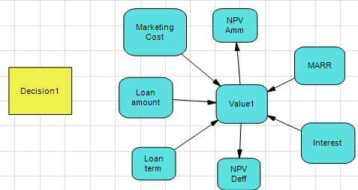

**Figure 10: Influence diagram for Deterministic Analysis - Value Sensitivity**

**Decision1 = What type of loan to push ?**

It can be observed that uncertainties such as Married, Education, Credit History and Loan Success are not included in this analysis, this is because they help the decision analysts define a decision policy, not the value of the decision. Figure 11 shows the tornado diagram for the above influence diagram.

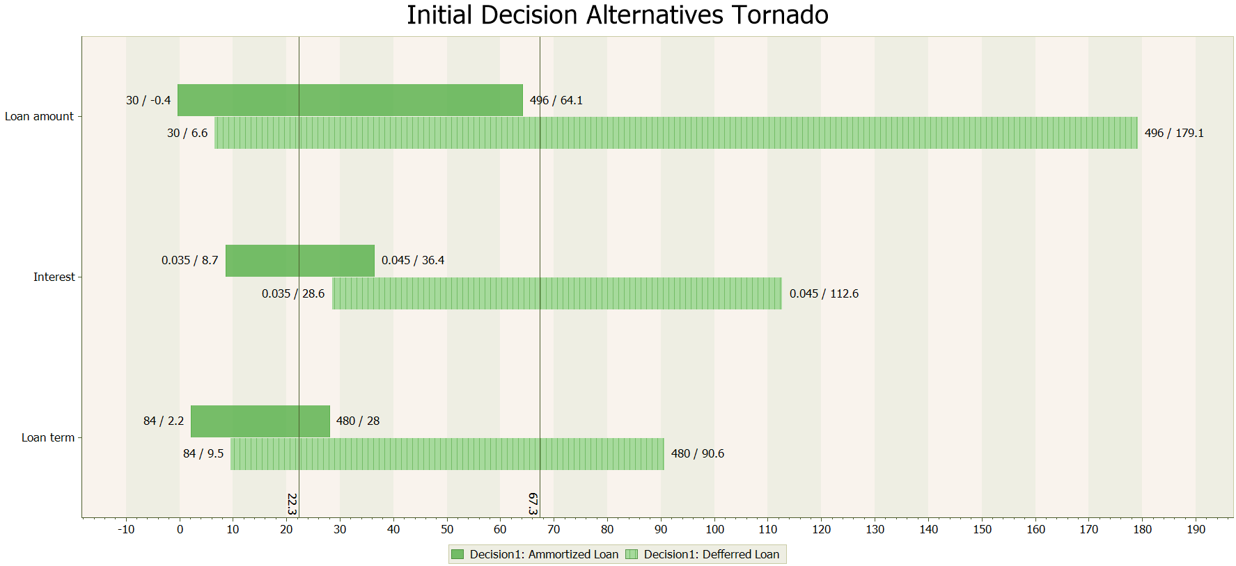

**Figure 11: Tornado Diagram for both Decision alternatives(Vertical lines show base Values)**

The tornado analysis shows no tornado dominance, since the none of the tornado diagrams are completely to the right of the other, also for the purpose of analysis it is better to consider all of the uncertain variables as material because variability in all of them causes huge changes in value of decision. Table 6 and 7 show the tornado analysis for each alternative in tabular form.

|  |  |  |  |  |  |  |  |
| --- | --- | --- | --- | --- | --- | --- | --- |
| Vars | Low Value | Base Value | High Value | NPV (Thousands) | | |  |
| LOW | HIGH | |∆| | Materials? |
| Loan_Amount (k $) | 30 | 194 | 496 | -0.4 | 64.1 | 64.5 | Yes |
| Interest | 3.5% | 4.0% | 4.5% | 8.7 | 36.4 | 27.7 | Yes |
| Loan_Term (Months) | 84 | 379 | 480 | 2.2 | 28 | 25.8 | Yes |

**Table 6: One-way Range Sensitivity Table - Amortized Loan**

|  |  |  |  |  |  |  |  |
| --- | --- | --- | --- | --- | --- | --- | --- |
| Vars | Low Value | Base Value | High Value | NPV (Thousands) | | |  |
| LOW | HIGH | |∆| | Materials? |
| Loan_Amount (k $) | 30 | 194 | 496 | 6.6 | 179.1 | 172.5 | Yes |
| Interest | 3.5% | 4.0% | 4.5% | 28.6 | 112.6 | 84 | Yes |
| Loan_Term (Months) | 84 | 379 | 480 | 9.5 | 90.6 | 81.1 | Yes |

**Table 7: One-way Range Sensitivity Table – Deferred Payment Loan**

In Table 6 & 7, the low, base and high values of uncertain variables are derived from the 3-point approximation of the respective theoretical distributions which is done by DPL (automatically). Also, in Figure 6 (Decision Tree – Base Model), it was observed that there is another decision alternative as well, incase Dream Home Financing chooses not to make an offer, the NPV in that case will be simply equal to zero.

# **Probabilistic Evaluation**

In probabilistic evaluations, the material uncertainties will be modelled by using theoretical probability distributions, selected by conducting KS-test and Chi-squared test, these were discussed in depth in the formulation phase and attached Jupyter Notebooks and Excel files. The size of the policy tree is very large to be shown here in-full, also since the task at hand is to define a decision policy for the Dream Home Financing’s CSR so different policy situations will be discussed here instead. Figure 12 shows the decision tree used for probabilistic analysis of the problem statement. Marketing Cost value is a **pay-type value** whereas all remaining assigned values are **get-type values**.

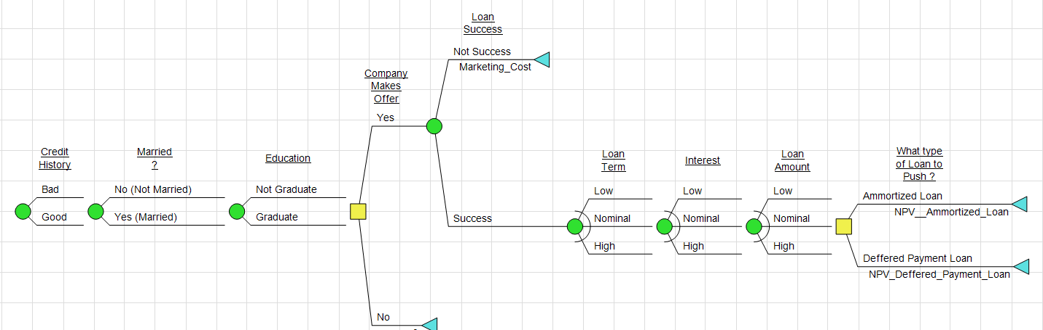

**Figure 12: Decision Tree for Probabilistic Analysis**

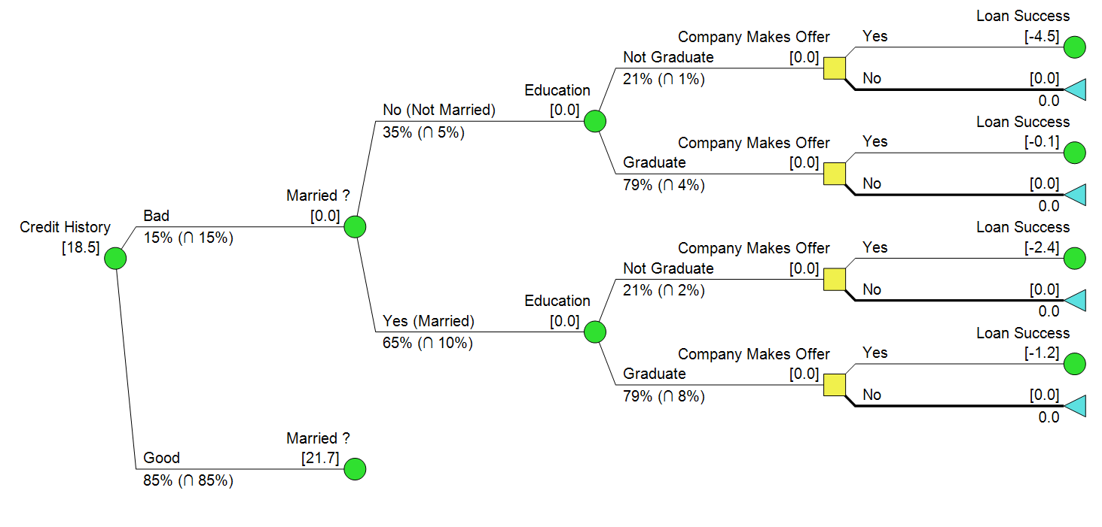After running the above decision model in DPL, Policy summary, Value of information and Policy tree is obtained.

**Figure 13: Upper portion of the policy tree. where company chooses not to make an offer based on available information.**

Figure 13, shows the specified chunk of Policy Tree where the company chooses not to make an offer, because of bad Credit History, not being a graduate (customer must not be doing a graduate-level job, i.e. low income) and not married (hence no chance of Co-applicant’s income meaning single source of income). It can be easily observed that the properties of the potential customer mentioned above do not suggest that the customer is looking for a home financing loan, hence inorder to avoid unecessary marketing costs the company should choose to avoid this customer. It is also observed that **if customer is graduate and is married even then solely based on Credit History the company should avoid making an offer** because the bad credit history suggests that customer is already spending more than he/she is earning.

In the policy summary, it also **seen if the the Credit History is good, company should always make an offer**, and if the **Interest is LOW then** **the company should push Amortized Loan.** The reason behind this phenomenon is the fact the if the offered interest is so LOW that it falls below the MARR, then company would loose money, the Amortized Loan will result in company loosing less money. This is also shown in Figure 14, which shows a sub-section of the policy tree.

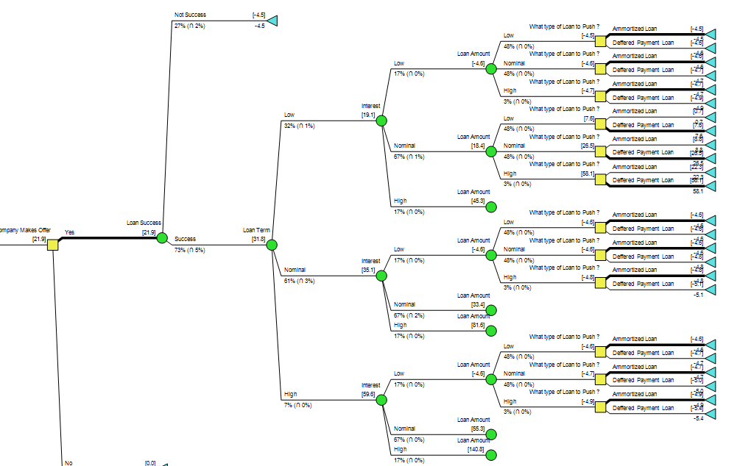

**Figure 14: A section of Policy tree, where Company has made an offer, but Interest is LOW**

On the contrary, **if the Interest is normal or high, and company is making an offer, then always Deferred loan should be pushed, this is done because in deferred loan the interest is compounded on a larger principal since there are no installements being deducted from it.** This behaviour can also be seen in the DPL file, since resulting Policy tree is very large so it will not be shown here.

These decision policies can be summarized into tabular form as shown in Table 8.

|  |  |  |  |
| --- | --- | --- | --- |
| Summary of the above probabilistic decision analysis. | | | |
|  | **Circumstances** | **Decision Policy** | **Takeaway points for CSR** |
| 1. | *Customers credit history is bad.* | Company does not extend any offer. | **NPV = 0.** |
| 2. | *Company extends an offer,*  *customer is interested in listening,*  *but interest is lower than MARR.* | Decision Policy dictates to push Amortized Loan package, but this costs the company additional money as shown in the Figure 14. | **Read just Interest-Rate by meeting with the leadership of the company, or don’t make an offer.** |
| 3. | *Company extends an offer,*  *customer is interested in listening,*  *but interest is higher than MARR.* | Decision policy dictates to push Deferred Payment loans as the NPV is much greater as compared to Amortized Loan Package. | **Offer Defered Loan Payment Package to the customer, as NPV is greater.** |

**Table 8: Summary of decision policy defined by decision analysis process**

The Table 8, highlights the important points for the CSR of the company, specially in point 2, CSR is required to revise the interest rate that was set on this offer, and this should be done by consulting with the leadership and informing them that the MARR set at the start of this project/analysis was higher than the said interest rate. This option can be added in the decision model as well by adding an additional decision alternative in second decision node, whose value is always equal to 4500 Dollars (i.e. Marketing Cost), but it left like this to highlight the fact **that inorder to have an NPV of more than 0, intrest rate should be set higher than MARR for the financial service/product.**

Next step in probablistic analysis is to determine if any option is stochastically dominant over the other by generating risk profiles, if this is the case then the recessive option is dropped, but since the goal of this decision analysis activity is to make an elaborate decision policy for Dream Home Financing by using historical data to assign probabilties to uncertainities, the decision analysts decide not to drop any options just yet. It can be observed that by using the policy tree the company can determine when to offer a package and which loan package to offer under what circumstances, with this information, the company CSR can implement this decision policy by flagging the subset of customers that fit these particular criteria and reaching out to them to offer the current or any future financial services or products.

# **What-If, Scenario and Option-Analysis**

The value of Information analysis for each uncertainity is conducted in DPL and results are shown in Figure 15.

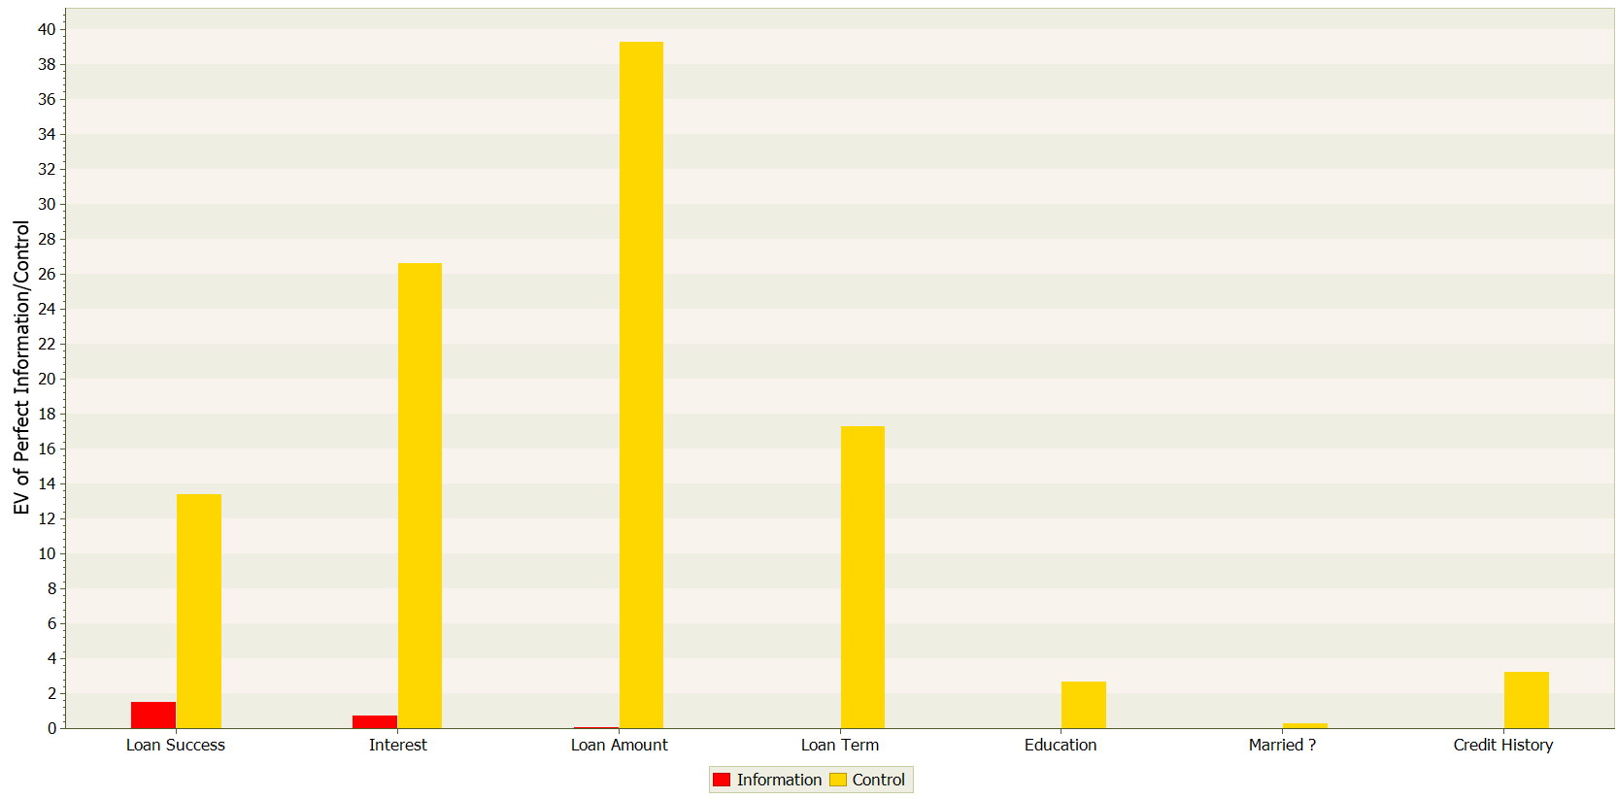

**Figure 15: Value of Information analysis results**

The value of information analysis shows both Expected value of Perfect Information and Control over the uncertainities. It can be seen Loan Amount provides the highest value of control, this means if Dream Home Financing can control the amount of money it has to lend to the customers then it will be most valuable to the company, on the other hand if the company has perfect information over Loan Success, meaning they somehow know whether they will be able to hook the customer or not, then this knowledge/information is most valuable to them, which makes sense because with this information, the CSR doesn’t have to worry about which customer will be interested and which will not be interested before the CSR-Customer interaction.

In case the **Perfect information over all uncertainities** is obtained by the Dream Home Financing, then the EV is raised to 32.6 Thousand dollars, as shown in Figure 16. This value was 18.5 in case of no Perfect information, hence the **EVPI = 32.6-18.5 => 14.1**.

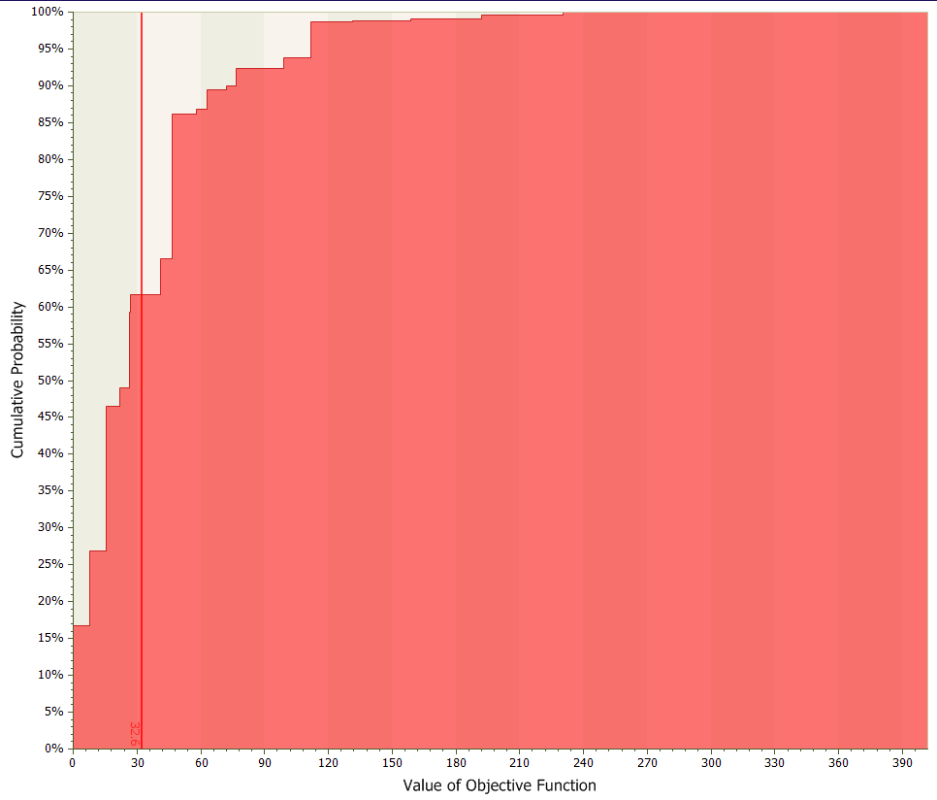

**Figure 16: Expected Value of the Complete Tree, when Every uncertainty is known**

# **Model Appraisal**

In the pass-through decision analysis cycle, decision analysts had assumed that Dream Home Financing was risk neutral and based on the expected values of the NPV, decision analysts were able to determine a decision policy for the CSR of the Dream Home Financing. The decision analysts didn’t conclude on the fact whether there is stochastic dominance or not, because the goal of the analysis was to define a decision policy for the CSR, so none of the alternatives could be dropped in the process in order to make a more generalized policy which explored all possible events.

Assuming the company is now Risk-Averse with an exponential utility function, the decision analysts chose to run sensitivity analysis on the value of Risk Tolerance where the Company never makes an offer to the Customer based on the current probabilities derived from data.

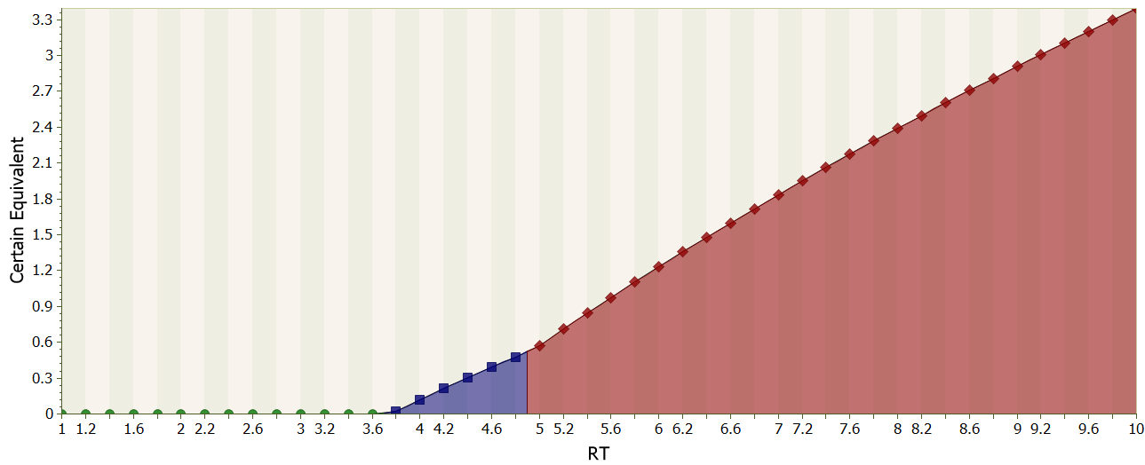

**Figure 17: One-way sensitivity analysis on Value of Risk Tolerance for Risk Averse case**

It can be observed from the Figure 17, that almost at a RISK TOLERANCE of 3.65 thousand dollars, the company chooses to never offer the loan to the customer. There is also a policy change at Risk Tolerance of 4.85 thousand dollars. The policy summary changes to this, “*What type of Loan to Push ?: Amortized Loan=10%, Deferred Payment Loan=49%, DNO=41%; Company Makes Offer: Yes=73%, No=27%”,* from this*, “What type of Loan to Push ?: Amortized Loan=6%, Deferred Payment Loan=31%, DNO=63%; Company Makes Offer: Yes=44%, No=56%”.*

# **Considerations of other factors**

Some of the uncertain variables from dataset were not considered in this analysis, which was basically conducted for setting up a decision policy for CSR of Dream Home Financing. These uncertain variables were dropped on the basis of the value of correlation co-efficient, although they can be included in this current model to define a much more diverse, comprehensive and complete decision policy.

Similarly, only two options were considered for loan packages, company’s leadership can also add multiple options for last decision node and calculate their NPV ranges using the past data. Usually MARR is decided in the beginning of the project and interest rate is always kept higher than MARR so that the financial product has positive NPV, this decision model emphasizes on the importance of this by showing negative NPVs when interest rates fall below the MARR. The theoretical distributions used to model the uncertain random variables are obtained by performing KS-Tests and Chi-squared tests, these distributions are the best possible approximations, but they are obviously not perfect.

# **Recommendation and Conclusions**

After completing all the decision analysis steps, it is clear from the established decision policy, that CSR of Dream House Financing should give the most preference to Credit history before making contact with customers, and it should make sure that the Interest rate offered in the package is higher than the MARR, otherwise the resulting NPV will be negative and the investment will be deemed not viable for the company.

The first decision node aims to solve a classification-type problem, and many machine learning models such as Support Vector Machines and random Forrest are proved to perform excellent in this area. Incase Dream House Financing was to upgrade their decision policy by incorporating these techniques in the analysis then the established policy will be much more effective and successful.

# **Attachments**

1. “LOAN.csv” – Dataset from Kaggle
2. “Probabilities and Dependence Assessment.ipynb” – Probability assessment using python
3. “Chi_Square-LoanTerm.xlsx” – Distribution fit Test to determine probabilities for LOAN Term
4. “Project.xlsx” – Base case for deterministic analysis
5. “DA - DreamHouseFinancing.da” – Decision Analysis in DPL
6. “CashFlows and NPV” – Cashflows and NPV analysis
7. “Poster.pptx”

# **References**

1. *Dream Home Financing, Official Page.*

[LINK]: <https://dreamhomefinancing.com/>

1. *Dream Home Financing Customer Dataset, Loan Predication | Kaggle.*

[LINK]:<https://www.kaggle.com/ninzaami/loan-predication>

1. *Minimum Acceptable Rate of Return | Typical Values*

[LINK]: <https://en.wikipedia.org/wiki/Minimum_acceptable_rate_of_return>

1. *Interest Rates in US for Home Financing.*

[LINK]:<https://www.usbank.com/home-loans/mortgage/mortgage-rates.html>

1. *Correlation Matrix and Correlation Coefficient Interpretation*

[LINK]: <https://www.investopedia.com/terms/c/correlationcoefficient.asp>

1. *Kolmogorov Smirnov Test for continuous random variables.*

[LINK]: <https://en.wikipedia.org/wiki/Kolmogorov%E2%80%93Smirnov_test>

1. *Chi-Squared Test, for discrete random variables.*

[LINK]: <https://en.wikipedia.org/wiki/Chi-squared_test>

1. *Amortized Loan*

[LINK]: [https://www.investopedia.com/terms/a/Amortized_loan.asp](https://www.investopedia.com/terms/a/amortized_loan.asp)

1. *Deferred Loan*

[LINK]: <https://www.investopedia.com/terms/d/deferred-interest-mortgage.asp>

1. *Loan Calculator*

[LINK]: <https://www.calculator.net/loan-calculator.html>